**eLeap Development Task**

Rev1.0 dated 12/10/2015

Task #1 Add new Maintenance tab



Maintenance

Maintenance tab consists of 3 options on the left window.

System Diagnostic

SPEC

Software Upgrade

* 1. System Diagnostic

This function requires for both embedded and PC Scale.

Diagnostic data is retrieved from **DIAGNOSTIC FILE - (E9H)**.

Diagnostic information is categorised into 2 groups – System Info and Scale Status

Scale Info

System

Scale Name - from eLeap

Scale IP Address - from eLeap

Scale Subnet

Scale Gateway

Scale MAC

Model

RAM Size

Storage Size

Software/Firmware

QT

PCScale

Printer

Touch Panel

Database

No. of Department

No. of Main Group

No. of PLU

Estimated Available PLU

Scale Status

Printer

Sensor Reading

Gap Sensor

Peel Sensor

Paper End

Sensor Status

Printing (Yes/No)

Cutter Busy (Yes/No)

Printer Busy (Yes/No)

Thermistor Warning (Yes/No)

Thermal Print Head Damage (Yes/No)

Cassette (Open/Close)

Thermal Print Head (Open/Close)

Paper End (Yes/No)

Peel Sensor (Yes/No)

Printing Media (Label/Receipt/Linerless)

PRINTER STATUS

BIT 5 – LINERLESS ACTIVE (1 = Linerless, 0 check BIT 11)

BIT 11 – LABEL SWITCH (0 = Receipt, 1 = Label)

*NOTE: For PC scale only.*

There should be 2 different display window for all the information.

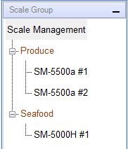

When click on Scale Management, it should display all scales under it, display each scale info by row. Refer to below for example.

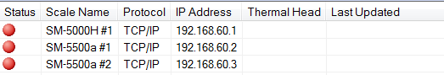

Information is to be separated by 2 tabs, Scale Info and Scale Status, on the right windows.

|  |  |  |
| --- | --- | --- |
| Scale Info | Scale Status |  |
|  |  |  |

*NOTE: Currently some of the information already done on Store > Scale Status option. This option is to maintain as it is to verify the network port for our scale (2000 + last set of IP) is opened for communication.*



* 1. SPEC

This function is still currently under study for implementation.

* 1. Software Upgrade

This function requires for PC scale only. Details will provide later.

QT

PC Scale software

Printer firmware

Touch Panel